NOTICE

The Board of Education of the Espanola Public Schools will hold
a Regular Board Meeting on Wednesday, January 19, 2022 at 5:30pm via
Google Meet from Espanola Public Schools Educational Services Center (ESC), Espanola, NM.

Meeting ID
meet.google.com/bcu-vofi-vkx
‬‬‬‬‬‬‬‬

CERTIFICATION
‬‬‬‬‬
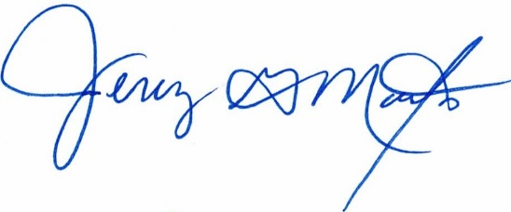

_____________________
Jeremy Maestas, President

